Excel Review

Bizmarket

Skills Covered

* Add borders
* Add headers to worksheets
* Apply a Quick Style to a chart
* Apply accounting and percent number formats
* Apply bold and italics
* Apply cell styles
* Apply conditional formatting
* Apply date and comma number formats
* Change the font face
* Change the font color
* Change the font size
* Check spelling
* Create a formula using the Insert Function button
* Create charts using column type formats
* Create formulas using the AVERAGE function
* Create formulas using the MAX function
* Create formulas using the MIN function
* Edit a chart
* Enter and edit text and numbers in cells
* Enter formula arguments (by clicking or typing)
* Fill adjacent cells with formulas
* Insert columns and rows
* Merge and center cells
* Modify column width
* Modify row height
* Modify worksheet names
* Move chart to a new worksheet
* Position a chart
* Reposition worksheets in a workbook
* Resize a chart
* Rotate text
* Save a workbook
* Select non-adjacent cells
* Set cell color
* Switch to a new worksheet
* Use absolute references
* Use the SUM function

Project overview

BizMarket is an online marketplace for people who want to buy or sell a small business such as a restaurant, convenience store, or car wash. You are an assistant to a financial analyst who requests a summary of financial statistics, such as the number and amount of sales made during the past five years. You’ve created an Excel workbook to calculate the statistics, and now need to complete and format the worksheets.

start FILE

**ExcelReviewData*.xlsx***

Instructions

1. Open the file **ExcelReview.xlsx** and save the file as **ExcelReviewComplete.xlsx** before you move to the next step. Place your name in cell B4 of the Documentation sheet.
2. Switch to Sheet1. In cell K1, enter **0.46** as the five-year success rate. In cell K2, enter **0.38** as the percentage of business valuation clients.
3. Make the formatting changes summarized in Table 1-1 to make the worksheet attractive and easy to read.

TABLE 1-1 Formatting Changes on Sheet1

|  |  |
| --- | --- |
| Cells | Formatting Changes |
| A1:A2 | **Title** cell style  **Times New Roman** font  **16-point** font size  **Purple, Accent 4** font color |
| C2 | **14-Mar-01** date format |
| H1:J1  H2:J2 | **Merge** cells  **Italics**  **Right** alignment |
| K1:K2 | **Percent Style** format  **no decimal** places |
| B3:D3  E3:G3  H3:J3  K3:M3 | **Merge and center** |
| A3:M3 | **Accent4** cell style |
| A4:M4 | **60% - Accent4** cell style  **Center** alignment |

1. In cell B7, enter a formula that calculates the number of auto parts businesses sold per buyer. Copy the formula in cell B7 to the range C7:M7 to calculate the number of businesses sold per buyer for other types of businesses.
2. In cell B13, enter a formula using the **SUM** function to calculate the total sales amount for auto parts businesses sold from 2009–2013. Copy the formula in cell B13 to the range C13:M13.
3. In cell B14, enter a formula that calculates the average sales amount for auto parts businesses. Copy the formula in cell B14 to the range C14:M14.
4. In cell B15, enter a formula using the **AVERAGE** function that calculates the average sales amount for auto parts businesses from 2009 to 2013. Copy the formula in cell B15 to the range C15:M15.
5. In cell B16, enter a formula using the **MAX** function that calculates the maximum sales amount for auto parts businesses from 2009 to 2013. Copy the formula in cell B16 to the range C16:M16.
6. In cell B17, enter a formula using the **MIN** function that calculates the minimum sales amount for auto parts businesses from 2009 to 2013. Copy the formula in cell B17 to the range C17:M17.
7. In cell B18, enter a formula that calculates the number of auto parts businesses expected to remain successful for at least five years. In the formula, use a relative reference to the number of businesses sold in cell B5 and an absolute reference to the “Five-year success rate to date” value in cell K1. Copy the formula in cell B18 to the range C18:M18.
8. Apply the Number Format **Accounting** to the ranges B8:M8 and B13:M17. Apply the Style Format **Comma** to the range B9:M12. Decrease the number of decimal places to zero in the range B8:M17.
9. Change the font color of the values in the range B13:M13 to **Purple, Accent 4**. Bold the values.
10. Add a **Top and Bottom Border** to the range B13:M13. Add a **Thick Bottom Border** to the range A18:M18.
11. For the range B14:M14, apply conditional formatting using Gradient Fill **Orange Data Bars** to show the variation in average sales amount per business. For the range B15:M15, apply conditional formatting using Gradient Fill **Green Data Bars** to show the variation in the average sales amount per year.
12. Make the formatting changes summarized in Table 1-2 to format the ranges B20:E25 and H20:K25.

TABLE 1-2 Additional Formatting Changes

|  |  |
| --- | --- |
| Cells | Formatting Changes |
| Row 20 | Height set to **24.00** points |
| B20:E20  H20:K20 | **Merge and center**  **Bold**  Fill color set to **Purple, Accent4, Lighter 60%** |
| B21:B25  H21:H25 | **Accent4** cell style  **Merge and center**  Rotated **up 90 degrees** |
| C21:C25  D21:E21  I21:I25  J21:K21 | **60% - Accent4** cell style |
| E22:E25  K22:K25 | **Currency** format, dollar symbol, no decimal places |

1. In cell D22, enter a formula to calculate the total number of automotive businesses sold. (These values appear in cells B5, C5, and D5.) In the range D23:D25, calculate the total number of businesses sold in the cleaning and maintenance (C&M), food and beverage (F&B), and retail categories, respectively.
2. In cell E22, enter a formula to calculate the total sales amount for automotive businesses sold. (These values appear in cells B13, C13, and D13.) In the range E23:E25, calculate the total sales amounts in the C&M, F&B, and retail categories, respectively.
3. In the range J22:J25, enter formulas to multiply the total number of businesses sold for each category (from the range D22:D25) by the percentage of business valuation clients (cell K2). In your formula, use an absolute reference to the value of the cell containing the percentage of business valuation clients.
4. In the range K22:K25, enter formulas to multiply the total sales amount for each category (from the range E22:E25) by the percentage of business valuation clients.
5. Apply a **Thick Box Border** to the ranges B20:E25 and H20:K25.
6. Increase the width of column A to **35.00** characters.
7. Insert a new row 27. Enter the following text in cell A27: \***Based on current success rate**. Format the text as italic.
8. Select the ranges A4:M4 and A13:M13 and then insert a 2-D Clustered Column chart for the selected ranges that shows the total sales amount in each business category in 2009-2013. Move the chart to a new sheet named **Sales Totals**.
9. Apply **Style 30** to the chart, and then remove the legend. Edit the chart title to be **Total sales 2009-2013**.
10. Rename Sheet1 to **Statistics**.
11. Move the Sales Totals chart sheet so that it becomes the last sheet in the workbook.
12. Add a header to the Statistics worksheet that displays the page number in the center of each page.
13. Change the orientation of the Statistics worksheet to **Landscape**.
14. Change the margins of the Statistics worksheet to **Wide**.
15. Check the spelling in the Statistics worksheet, making corrections as appropriate. Your final worksheets should look similar to Figures 1-1, 1-2, and 1-3.

Save your changes, close the document and exit Excel. Upload your solution to Blackboard.

FIGURE 1-1

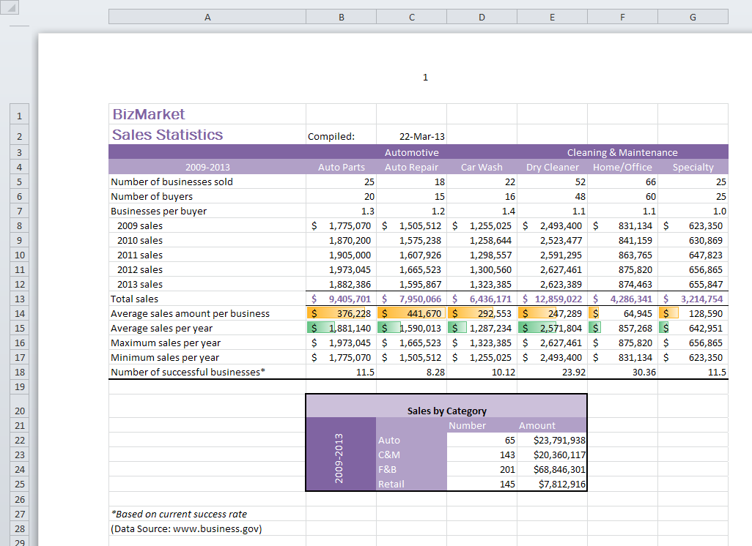

FIGURE 1-2

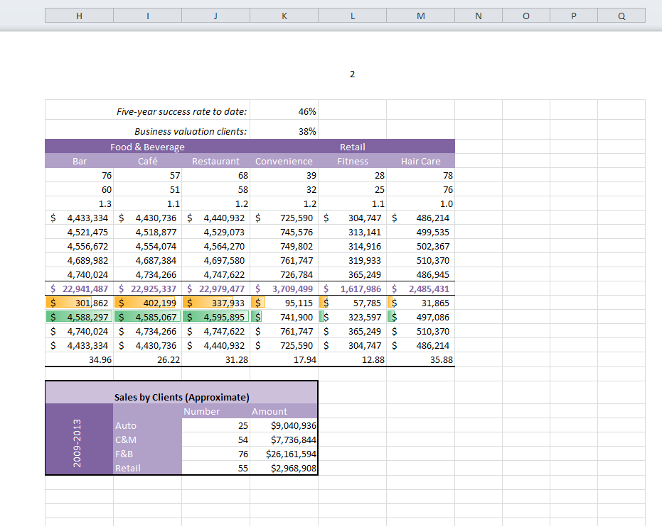

FIGURE 1-3

**SAM 2010 Excel Capstone B Fig 1-3 .tif**